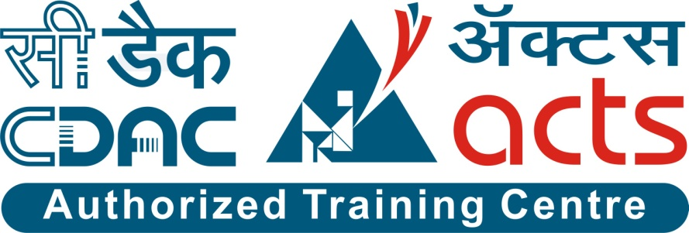

Project Name: Online Electricity Bill Management System

Branch PG-DAC March-2022

Documentation On

**“Online Electricity Bill Management System”**

PG-DAC MARCH 2022

**Guided By: Prathamesh Naik**

Submitted By :

**Group No: 15**

* **Ravindra Mohite 220343020050**
* **Priya Patil 220343020065**
* **Shruti Patil 220343020066**
* **Varsha Patil 220343020069**

**Table of Contents**

**1. Introduction 4**

1.1 Document Purpose **4**

1.2 Project Background **4**

1.3 Aim & Objectives **4**

**2. Business Requirements Overview**…………………………………………………………**5**

**3.Functional Requirements** **6**

3.1 Consumer Module **6**

3.2 Sub-Admin Module **6**

3.3 Admin Module **6**

**4.** **Non-Functional Requirement………………………………………………………………7**

**5. Use Case Diagram 8**

5.1 Admin **8**

5.2 Sub-Admin **9**

5.3 Consumer **10**

**6. Database Design 11**

1 Users **11**

2 Admin **11**

3 Sub-Admin...……………………………………………………………………………..**11**

4 Consumer **12**

5 Zone **12**

6 Bills **12**

7 Payment details **13**

**7. E-R Diagram……………………………………………………………………………………….14**

**8. Snapshots 15**

**9. Conclusion 23**

**List of Figures**

**Use Case Diagrams 17**

Fig 1 Admin 8

Fig 2 Sub-Admin 9

Fig 3 Consumer 10

Fig 4 ER Diagram 14

1. **Introduction:**
   1. **Document Purpose:**

This document communicates the business requirements and scope for developing Online Electricity Bill Management System. The scope of this document is to define the functional and non functional requirements, business rules and other constraints requirements.

## Project Background:

This system is made to keep the records about the bills of the consumers. In current system getting previous data of paid bills is difficult task. Payment of the bills using current system is also difficult task.

## Aim & Objectives:

The main objective of this project is building a website which will help to manage the details of electricity bills, connections, store records and consumers. Sub-admins are allocated on the basis of different regions. Here if suppose anyone wants to use this facility and pay electricity bills online then they must have knowledge of computer. After that they can directly register in the portal by providing their valid details and pay electricity bill online.

This system has the option for consumers to pay their electricity bills by online mode through card payment. This system also has the feature to add and delete consumers and sub-admin accounts, in case a consumer wants to cut the connection or a sub-admin wants to leave the job.

1. **Business Requirements Overview:**

* Online Electricity Bill Management System is a public web application.
* Online Electricity Bill Management System will be available for all consumers which want to pay their electricity bills online by using this portal.
* There are mainly three types of users.
* To register on this portal consumers should provide their valid Email-id and Contact number.
* Consumer can view details of electricity bills by logging into their account.
* Admin, sub-admin can search electricity bill payment details and even information about the consumer by using a unique id which is generated for every consumer.
* Online Electricity Bill Management System could be maintained by Admin.

# Functional Requirements Overview:

Online Electricity Bill Management System consists of three modules described below:-

1. Admin Module
2. Sub-admin Module
3. Consumer Module

**3.1 Admin:**

Enter Admin Email-Id and Password.

* + Display the Admin dashboard where he can see his profile and update his profile.
  + Admin can add and delete sub-admin.
  + Admin can delete the consumer.
  + Admin can add zone.
  + View number of consumers, sub-admins by zone.
  + Generate bills by particular consumer Id.
  + Can view bill payment reports by particular consumer Id.

**3.2** **Sub-Admin:**

Enter Sub-Admin Email-Id and Password.

* Display the Sub-Admin dashboard where he can see his profile and update his profile.
* View number of consumers.
* Sub admin can delete the consumer.
* Generate bills by particular consumer Id.
* Can view bill payment report by particular consumer Id.

**3.3 Consumer:**

Enter consumer Email-Id and Password

* Display the consumer dashboard where he can see his profile and update his profile.
* View current bill.
* Consumer can pay bill using card payment.
* Consumer can view bill payment history.

1. **Non-Functional Requirement:**

* The website should use professional design, look and feel and color scheme.
* Users will have no limitations for accessing the application through Internet. The portal being an internet application, it is difficult specify exact number of visitor or users. Hence we will target the system to support between 5 and 10 million users on launch of phase 1.
* Being a public website, the site must follow general usability guidelines for menus, navigation, colors, links and other actions provided on the screens.
* The system should be designed in such a manner that user will be able to complete tasks in minimum number of steps.

## Use-Case Diagram

**5.1 Admin:**

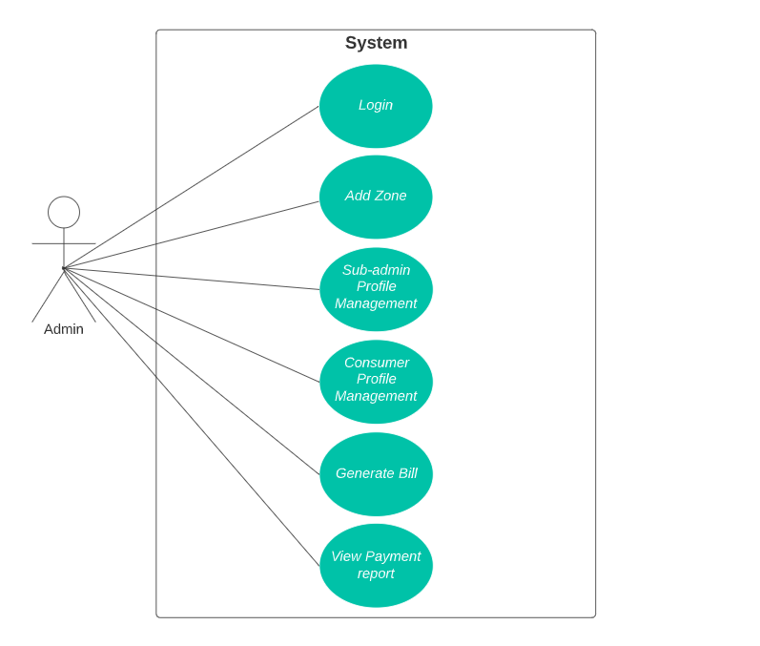

Fig. Use-Case Diagram for Admin

## 5.2 Sub admin:

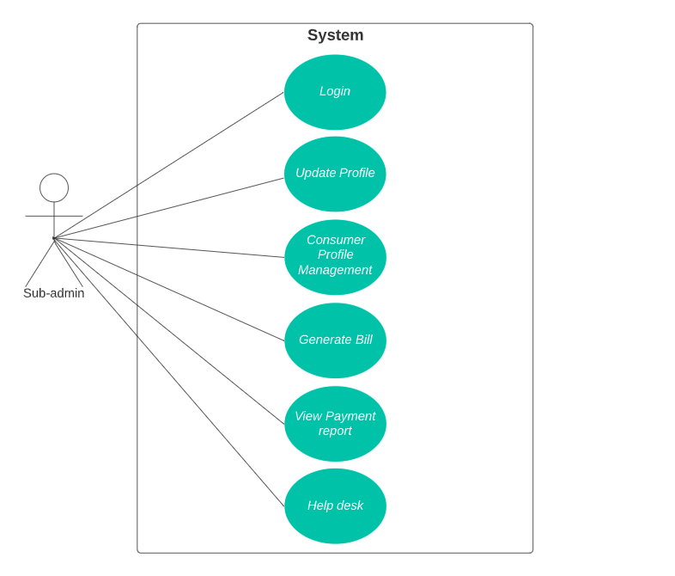

Fig. Use-Case Diagram for Sub admin

**5.3 Consumer:**

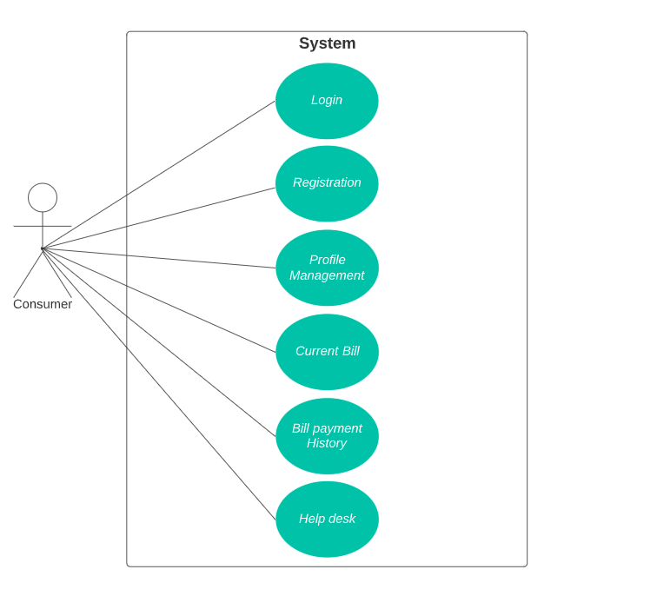

Fig. Use-Case Diagram for Consumer

1. **Database Design:**

**1] users table**

|  |  |  |  |
| --- | --- | --- | --- |
| **Fields** | **Data types** | **Constraints** | **Description** |
| user_id | int | PK,AI | User ID |
| email | varchar(40) | Unique,NN | Email address |
| password | varchar(25) | NN | Password |
| role | varchar(10) | NN | User role |

**2] admin table**

|  |  |  |  |
| --- | --- | --- | --- |
| **Fields** | **Data types** | **Constraints** | **Description** |
| user_id2 | int | FK | User ID |
| admin_id | int | PK,AI | Admin ID |
| name | varchar(40) | NN | Name |
| mobile_no | varchar(10) | NN | Mobile number |
| address | varchar(100) | NN | Address |
| city | varchar(30) | NN | City |
| email | varchar(40) | Unique, NN | Email address |
| state | varchar(30) | NN | State |

**3] sub_admin table**

|  |  |  |  |
| --- | --- | --- | --- |
| **Fields** | **Data types** | **Constraints** | **Description** |
| user_id1 | int | FK | User ID |
| subadmin_id | int | PK,AI | Sub Admin ID |
| name | varchar(40) | NN | Name |
| mobile_no | varchar(10) | NN | Mobile number |
| address | varchar(100) | NN | Address |
| city | varchar(30) | NN | City |
| email | varchar(40) | Unique, NN | Email address |
| state | varchar(30) | NN | State |
| zone_id1 | int | FK | Zone ID |

**4] consumer table**

|  |  |  |  |
| --- | --- | --- | --- |
| **Fields** | **Data types** | **Constraints** | **Description** |
| user_id | int | FK | User ID |
| consumer_id | int | PK,AI | Consumer ID |
| name | varchar(40) | NN | Name |
| mobile_no | varchar(10) | NN | Mobile number |
| address | varchar(100) | NN | Address |
| city | varchar(30) | NN | City |
| email | varchar(40) | Unique, NN | Email address |
| state | varchar(30) | NN | State |
| zone_id | int | FK | Zone ID |

**5] zone table**

|  |  |  |  |
| --- | --- | --- | --- |
| **Fields** | **Data types** | **Constraints** | **Description** |
| zone_id | int | PK,AI | zone_id |
| zone_name | varchar(30) | NN | zone_name |

**6] bills table**

|  |  |  |  |
| --- | --- | --- | --- |
| **Fields** | **Data types** | **Constraints** | **Description** |
| bill_id | int | PK,AI | Bill ID |
| consumer_id | int | FK | Consumer ID |
| units | int | NN | Units consumed |
| current_billAmt | double | NN | Current bill amount |
| dues | double | NN | Dues |
| fine | double | NN | Fine |
| total_billAmt | double | NN | Total bill amount |
| tax | double | NN | Tax |
| bill_date | date | NN | Bill date |
| due_date | date | NN | Due date |
| status | varchar(20) | NN | Status |

**7] payment_details table**

|  |  |  |  |
| --- | --- | --- | --- |
| **Fields** | **Data types** | **Constraints** | **Description** |
| payment_no | int | PK,AI | Payment ID |
| consumer_id1 | int | FK | Consumer ID |
| bill_id | int | FK | Bill ID |
| name | varchar(40) | NN | Name |
| payment_date | date | NN | Payment date |
| total_billAmt | double | NN | Total bill amount |
| card_type | varchar(15) | NN | Card type |
| card_no | varchar(16) | NN | Card no |
| cvv | varchar(4) | NN | CVV |
| exp_date | date | NN | Expiry date |

## ER-Diagram:

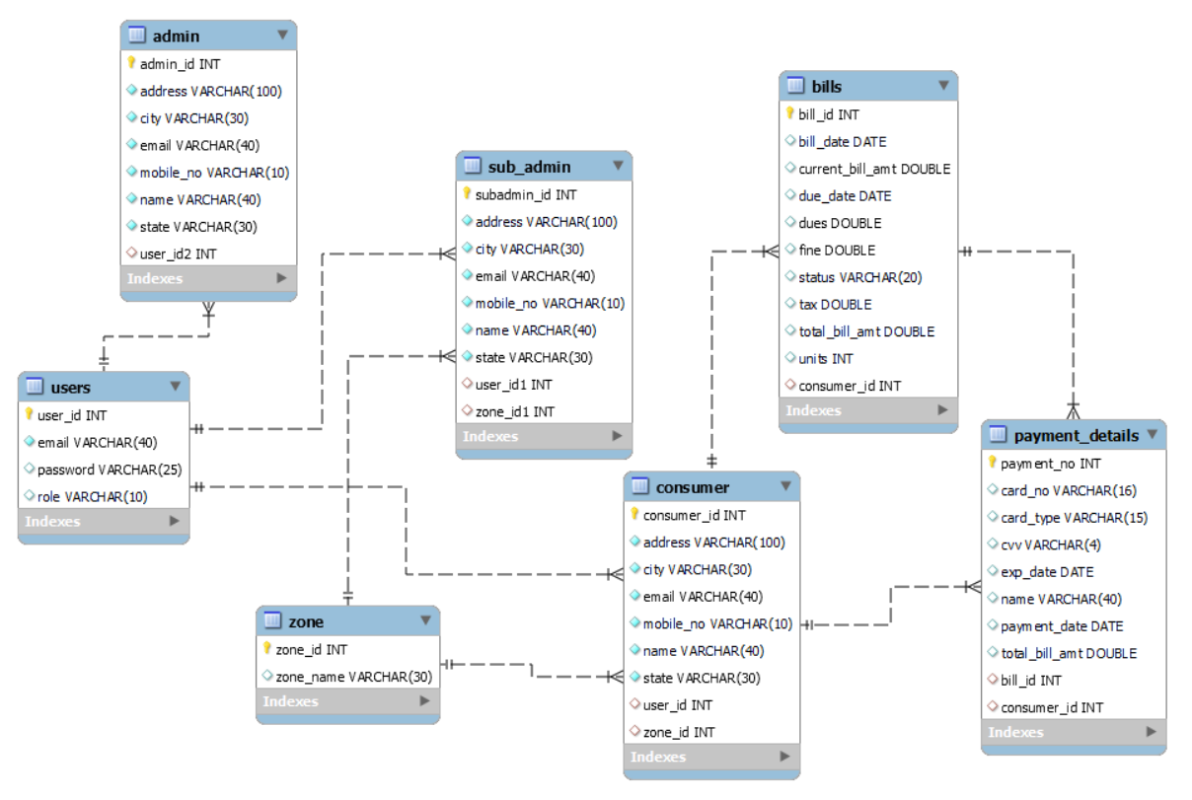

**E-R diagram shows database of Online Electricity Bill Management System**

1. **Snapshots:**

**8.1 Home Page:**

Following snapshot shows the Home page for Online Electricity Bill Management System

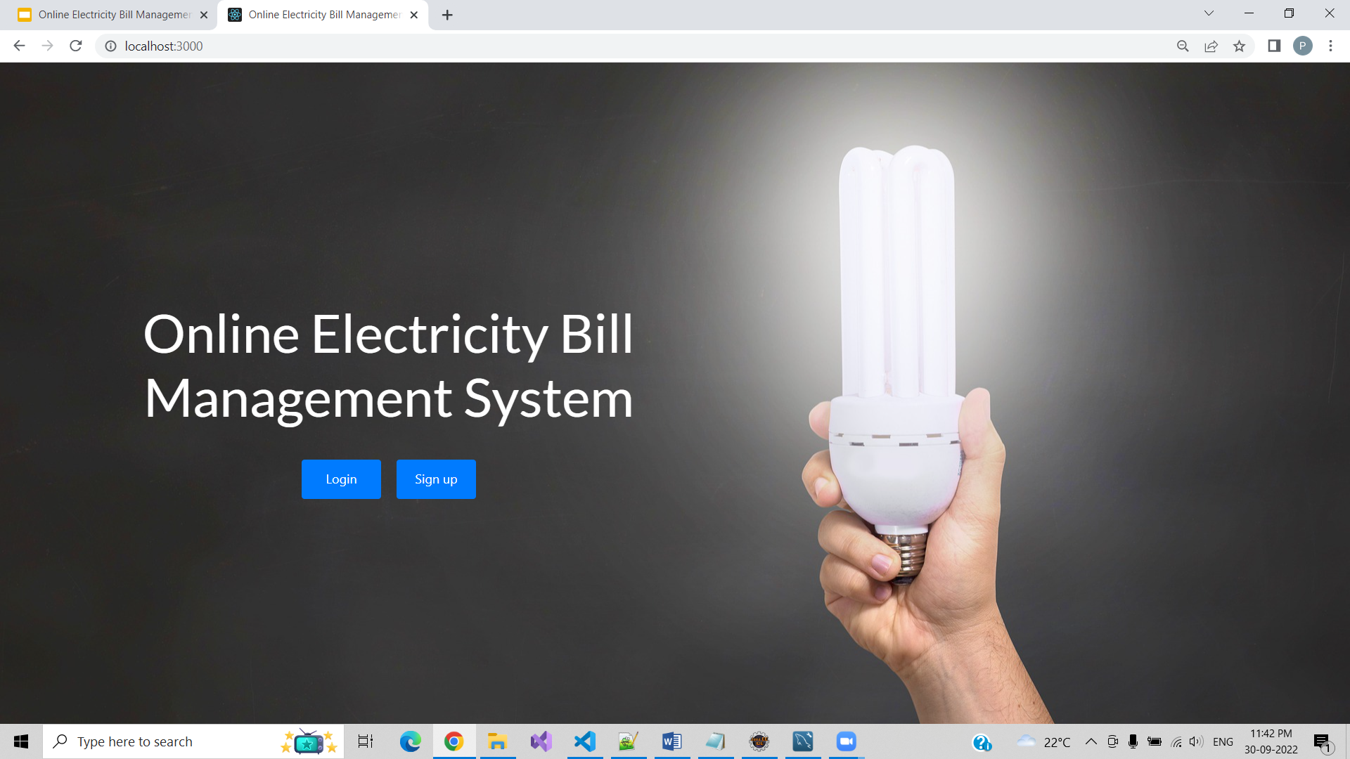

This page contains following controls

* Login
* Sign up

**8.2 Login Page for User**

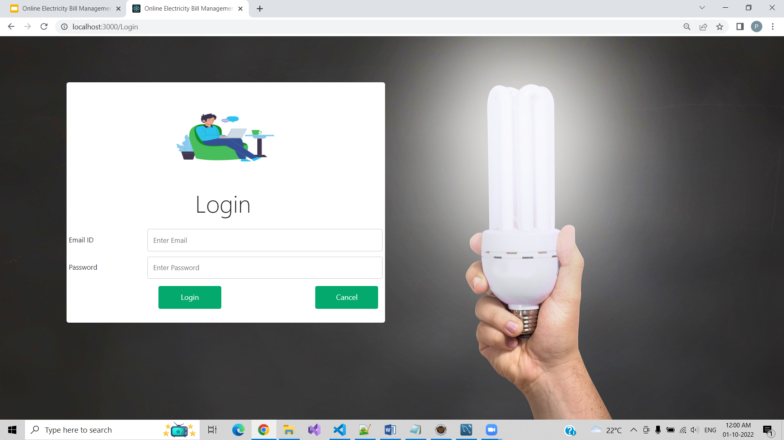

**8.3 Sign up Page for Consumer**

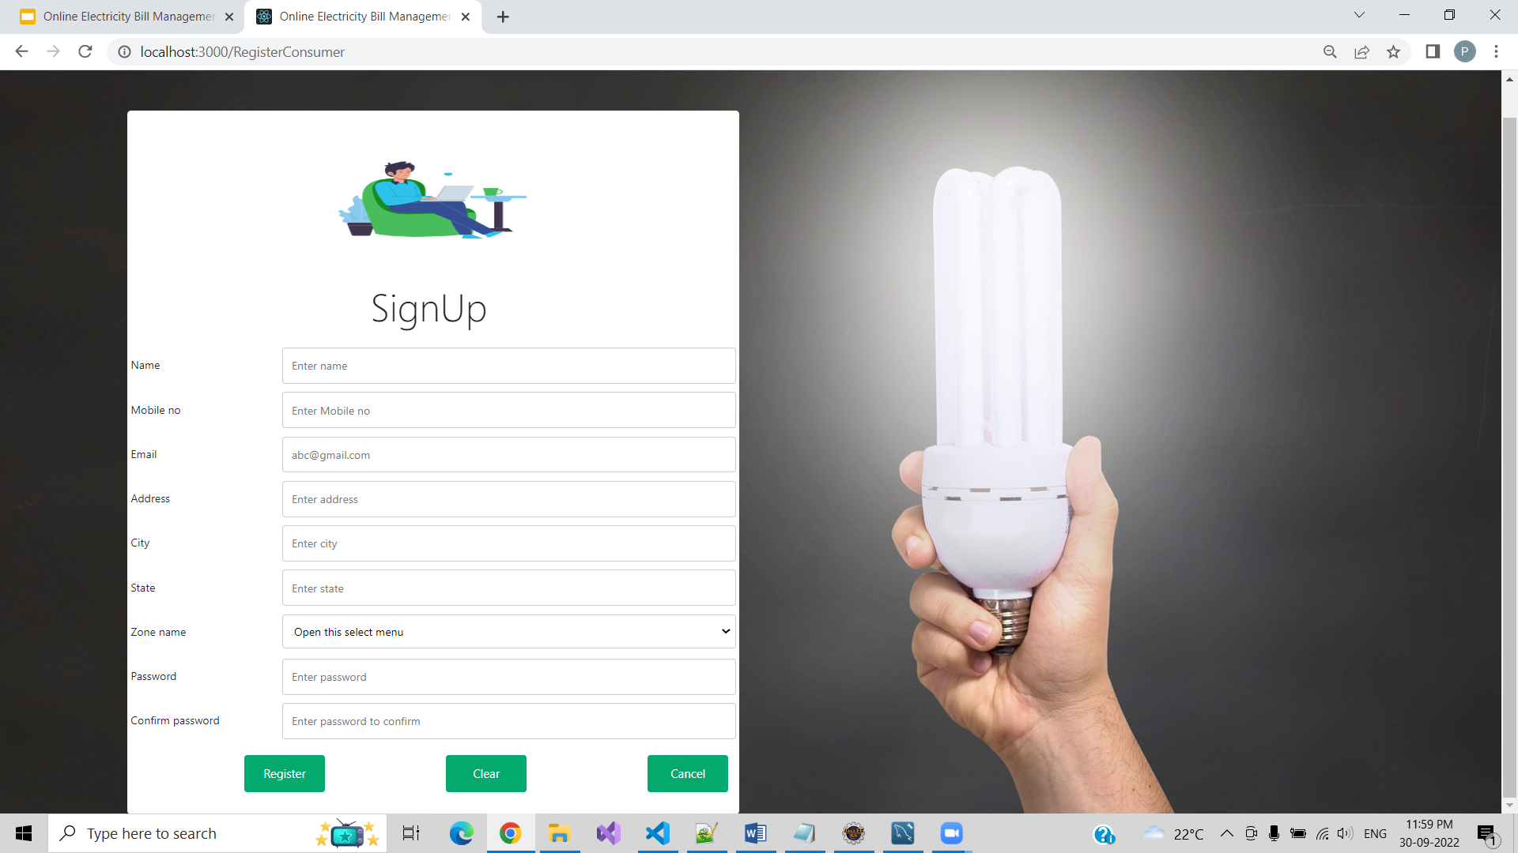

**8.4 Admin**

**8.4.1 Admin Home Page**

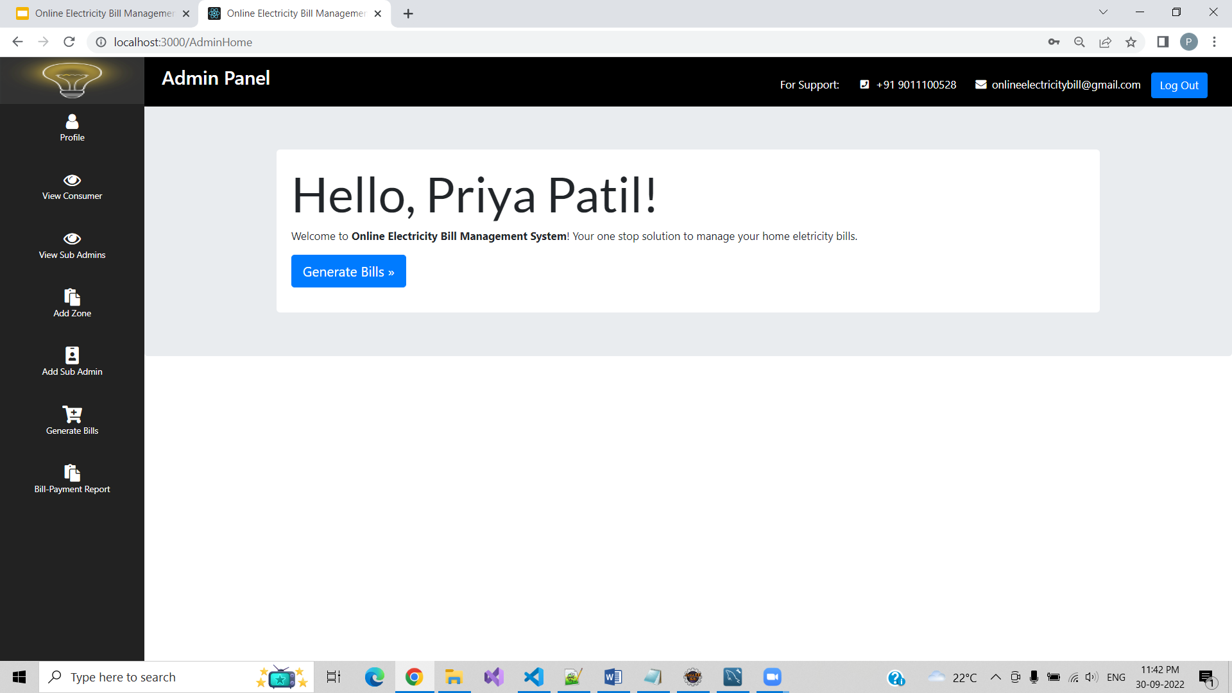

**8.4.2 Add Zone Page**

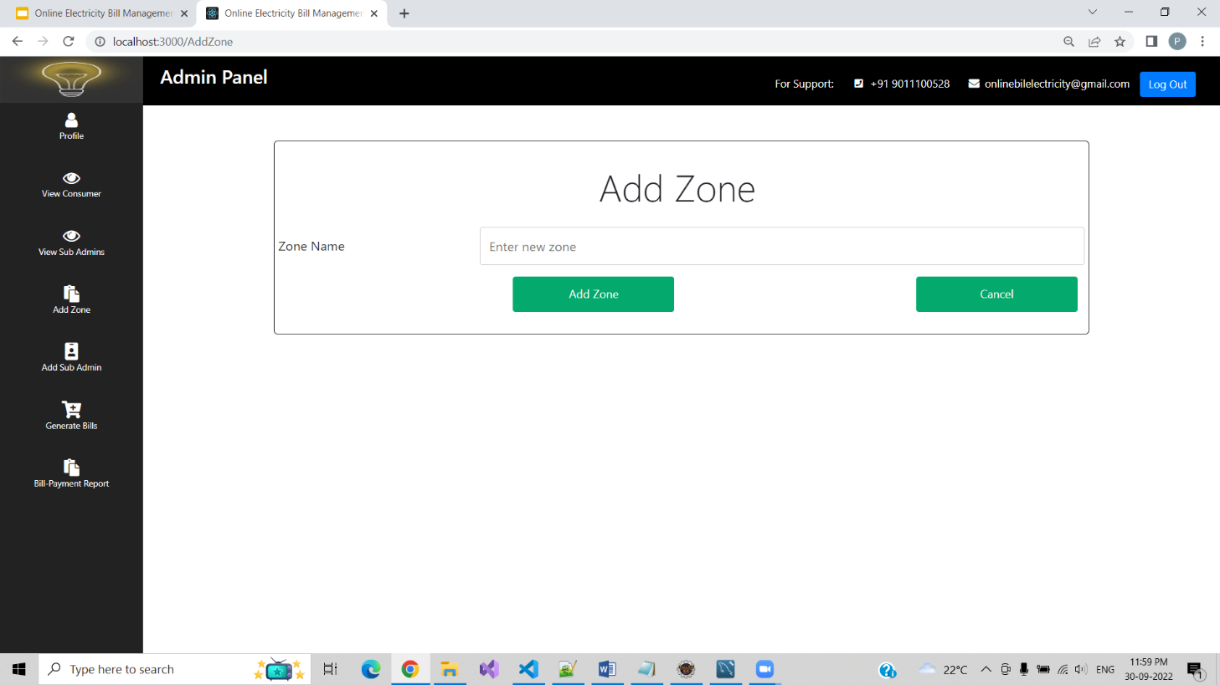

**8.4.3 Bill Generation Page**

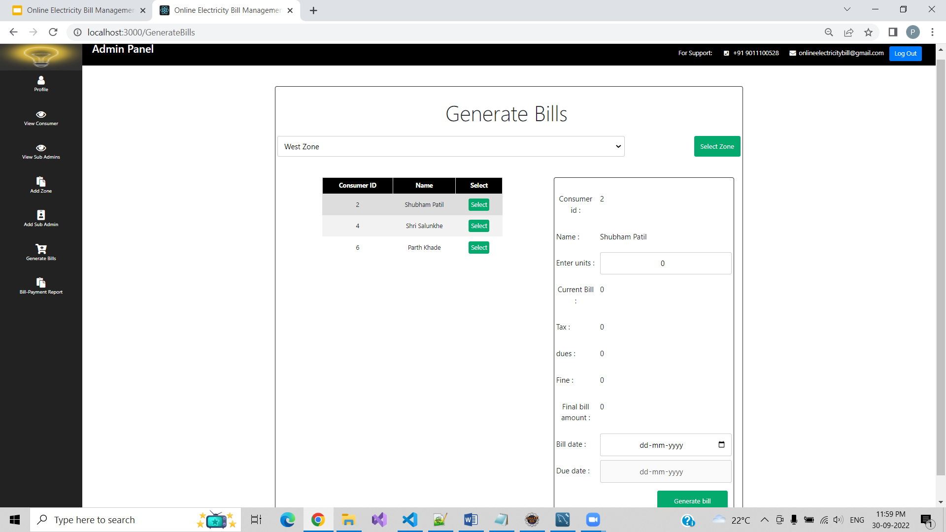

**8.4.4 Bill-Payment Report**

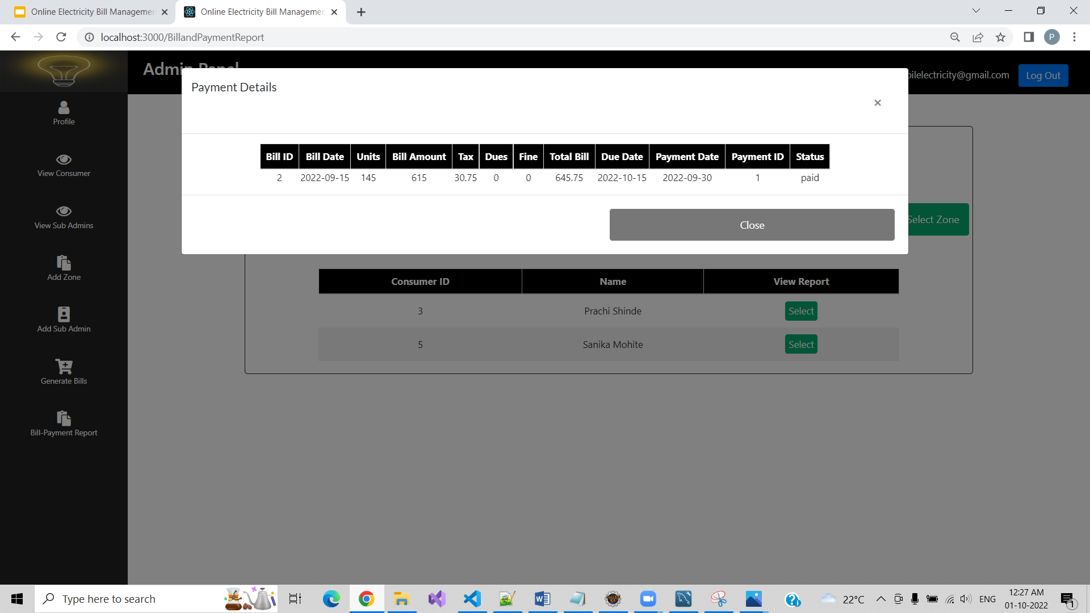

**8.5 Sub-Admin**

**8.5.1 Sub Admin Page**

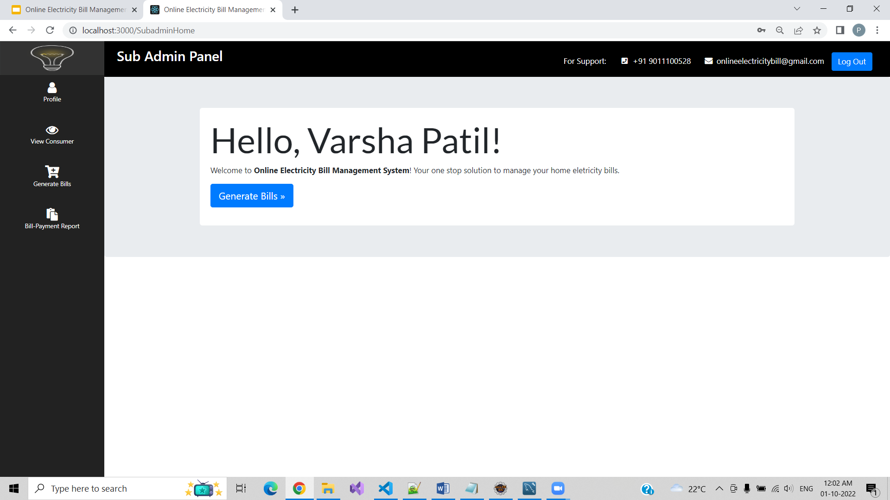

**8.5.2 View Consumer Page**

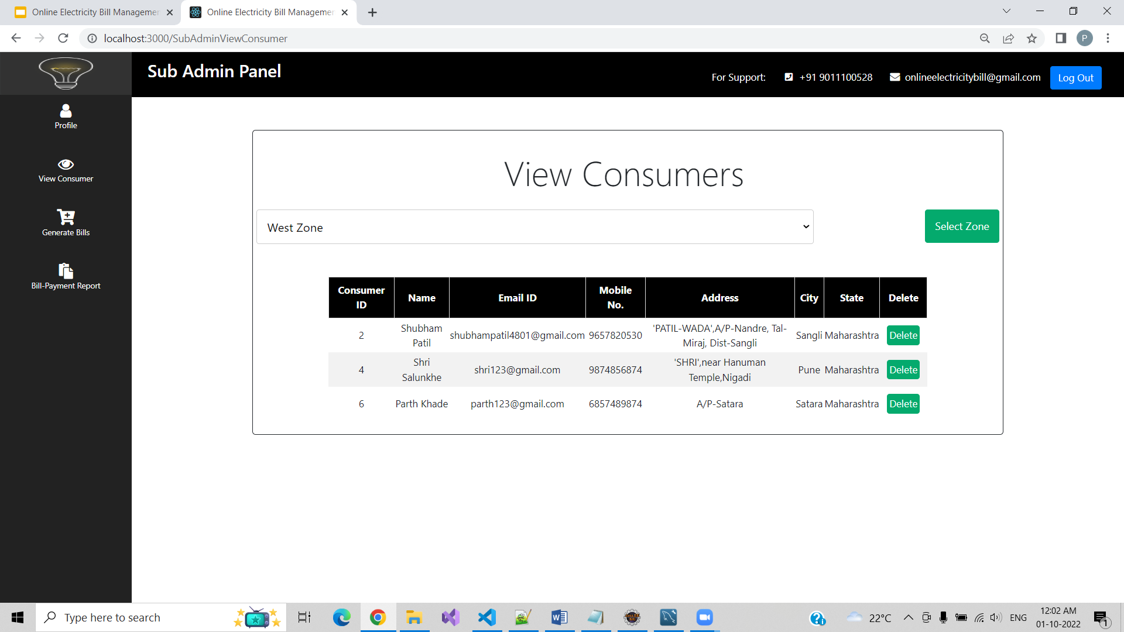

**8.5.3 Generate Bill Page**

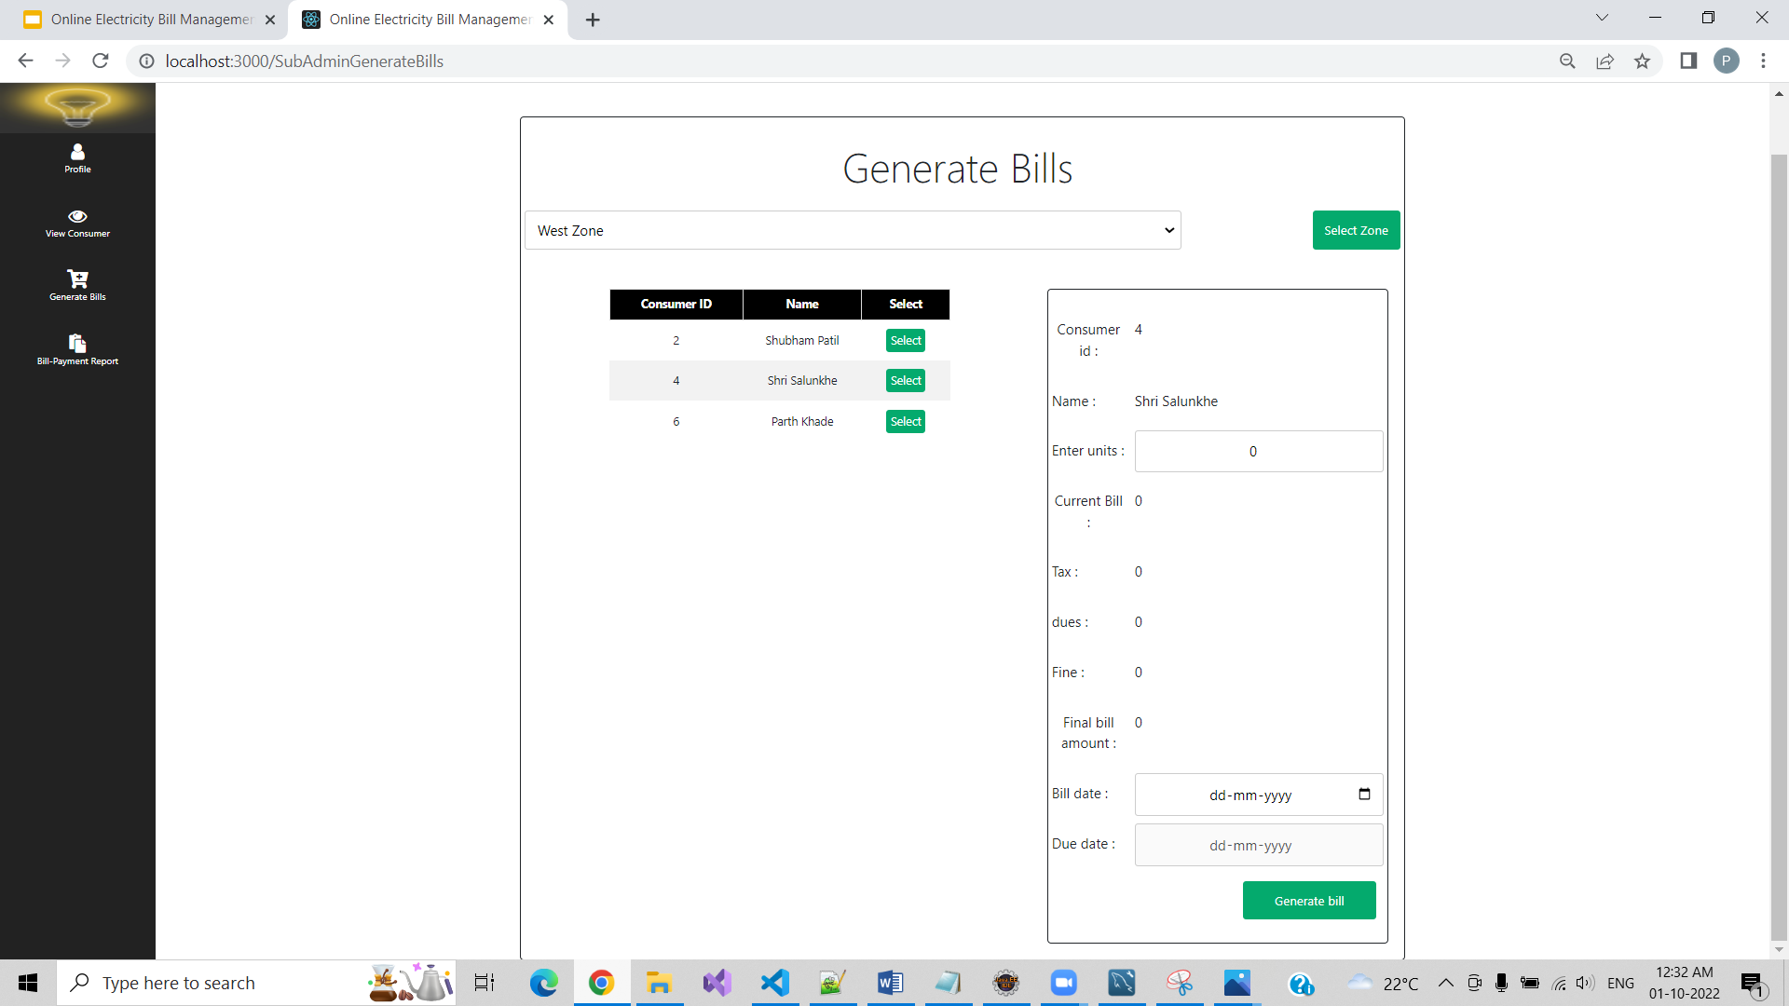

**8.5.4 Bill Payment Report Page**



**8.6 Consumer**

**8.6.1 Consumer Home Page**

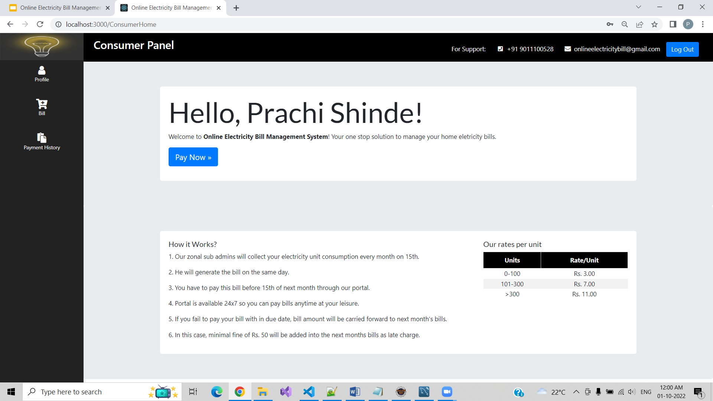

**8.6.2 Pay Bill Page**

**a. Pending Bill**

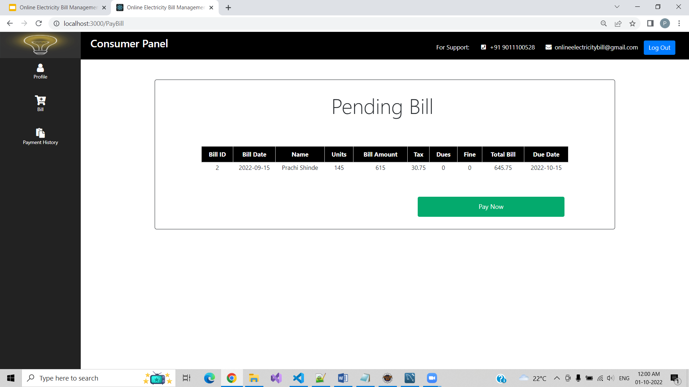

**b. Pay Bill**

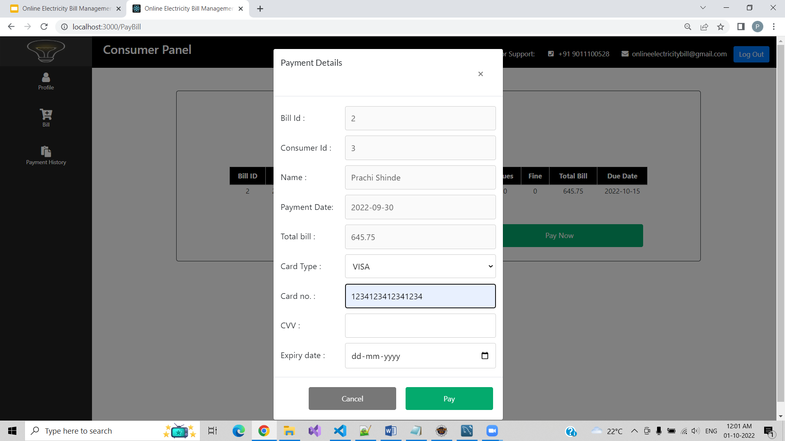

**8.6.3 Payment History Page**

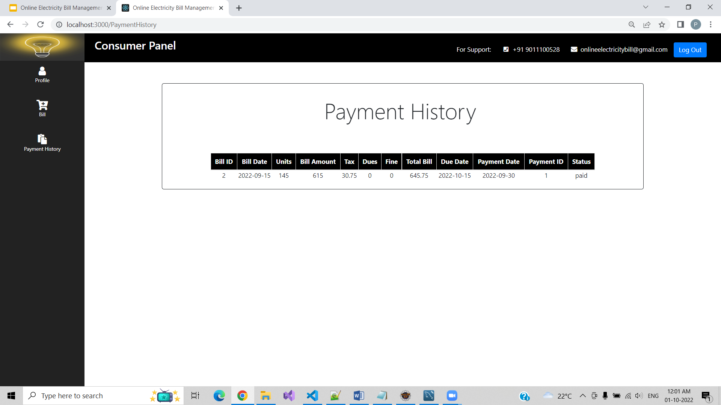

1. **Conclusion And Future Scope**

* It is software that helps the user to work with the billing cycles, paying bills.
* This software reduces the amount of manual data entry and gives greater efficiency.
* By using this application calculations are performed automatically during generation of bill on the basis of unit consumption.
* The user interface is very friendly and can be easily used by anyone.